Getting started with ed1stop student portal for research

Ed1stop is available for use by all WCCUSD students at any computer with Internet access.

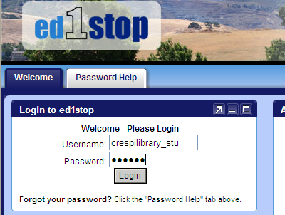

www.Ed1stop.net
Username: (get at the school library)
Password: (get at the school library)
Log in

Agree to terms of service? OK

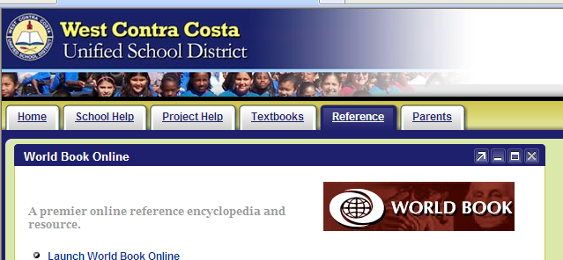
Click Reference tab
Click Launch World Book Online
(or click World Book icon)

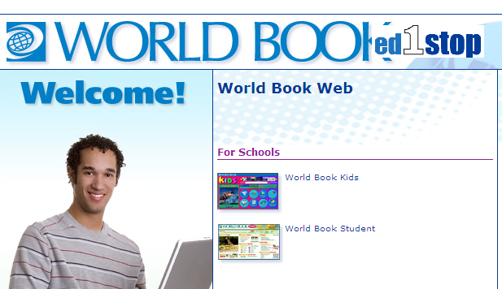

Click on World Book Student

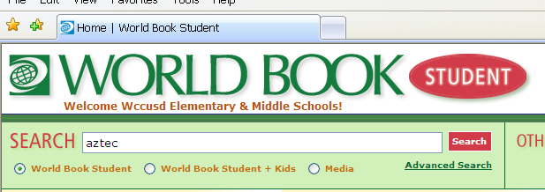
Enter keyword into search box
Submit

